

## PAK–ARAB REFINERY LTD.

## TO WHOM IT MAY CONCERN

It is certify that **Mr. <Name> S/o <fname>** has worked in ***Pak Arab Refinery Ltd.*** Mehmood Kot Distt. Muzaffargarh as a **<Designation>** through contractors Al-Mubeen & Company in project work from ***<From>*** to ***<To>.***

He is hard worker, honest and obedient to his seniors.

# We wish him success in Future life.

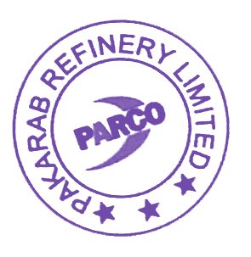Yours faithfully,

For PAK-ARAB REFINERY LIMITED



Ahsan Kamal

Manager

Human Resource Development